
Tribhuvan University
Institute of Science and Technology

A Project Report
On
"Plagiarism Checker for NCCS"

Submitted to
Department of Computer Science and Information Technology
National College Of Computer Studies(NCCS)
Paknajol , Kathmandu

In partial fulfillment of the requirements for the bachelor’s in computer science and information technology

Submitted by
Sabhyata Aryal (NCCSCSIT 519)

Under the supervision of
Nabaraj Bahadur Negi


National College of Computer Studies
Paknajol, Kathmandu

SUPERVISOR’S RECOMMENDATION
I hereby recommend that the dissertation prepared under my supervision by Sabhyata Aryal, 79010741, 5-2-551-28-2022, entitled “Plagiarism Checker for NCCS” be accepted as fulfilling the partial requirements for the degree of Bachelor’s in Computer Science and Information Technology.
Throughout the course of this project, Sabhyata Aryal has demonstrated dedication, technical competence, and a clear understanding of the research objectives. The work has been carried out sincerely and meets the academic standards and requirements set by the department.
I am satisfied with the quality of the dissertation and recommend it for evaluation and approval.

……………………………
Mr. Nabaraj Bahadur Negi
Supervisor
National College of Computer Studies(NCCS)
Paknajol, Kathmandu

Acknowledgement

First of all, I would like to express my sincere gratitude to my project supervisor for his continuous guidance, valuable suggestions, and constant encouragement throughout the development of this project. His constructive feedback and technical insights played a significant role in shaping the direction and successful completion of this plagiarism detection system.
I am also deeply thankful to the National College of Computer Studies (NCCS) and the Department of Computer Science and Information Technology for providing the academic environment, necessary resources, and institutional support required to carry out this project effectively.
Finally, I would like to extend my heartfelt appreciation to my family and friends for their continuous encouragement, motivation, and support during the entire course of this project.

Abstract

Academic integrity is essential in higher education, particularly in the evaluation of final year project reports. With the increasing availability of digital content and repeated submissions across academic batches, the risk of plagiarism has grown significantly. Manual plagiarism checking is time-consuming, inefficient, and unreliable when handling a large number of documents. Therefore, there is a need for an automated system that can efficiently verify the originality of student reports.
This project proposes a web-based plagiarism detection system for NCCS that maintains a centralized repository of previously submitted project reports. Teachers can upload new reports, and the system automatically extracts and preprocesses text from PDF and DOCX files. The plagiarism detection mechanism is implemented using an N-gram–based approach combined with Jaccard similarity, where documents are divided into word sequences and compared based on the overlap between their N-gram sets.
The system calculates similarity percentages and identifies matched documents, enabling teachers to evaluate student submissions accurately and efficiently. By automating the comparison process, the proposed system reduces manual workload, improves reliability, and strengthens academic integrity within the institution.

Table of Contents
Chapter 1: Introduction 1
1.1 Introduction 1
1.2 Problem Statement 1
1.3 Objective 2
1.4 Scope and Limitation 2
1.4.1 Scope: 2
1.4.2 Limitation 2
1.5 Development Methodology 2
1.6 Report Organization 3
Chapter 2: Background Study and Literature Review 5
2.1 Background Study 5
2.2 Literature Review 5
Chapter 3: System Analysis 7
3.1 System Analysis 7
3.2 Requirement Analyis 7
3.2.1 Functional Requirements 7
Use Case Description 8
3.2.2 Non-functional Requirements 8
3.3 Feasibility Analysis 9
3.3.1 Economic Feasibility 9
3.3.2 Technical Feasibility 9
3.3.3 Operational Feasibility 9
3.3.4 Schedule Feasibility 9
3.4 Analysis (Object oriented approach) 10
3.4.1 Object Modelling 10
3.4.1.1 Class Diagram 10
3.4.1.2 Object Diagram 10
3.4.2 Dynamic Modelling 11
3.4.2.1 Sequence Diagram 11
3.4.2.2 State Diagram 12
3.4.3 Process Modelling 13
3.4.3.1 Activity Diagram 13
Chapter 4: Algorithms Used 14
4.1 N-Gram Based Similarity with Jaccard Similarity 14
Chapter 5: Overall Project Completion 16
5.1 Completed Work (50%) 16
5.2 Work Remaining (50%) 17

List of Figures
Figure 1 Development methodology (waterfall model) 3
Figure 2 Use Case Diagram 8
Figure 3 Gantt Chart 9
Figure 4 Class Diagram 10
Figure 5 Object Diagram 10
Figure 6 Sequence Diagram 11
Figure 7 State Diagram 12
Figure 8 Activity Diagram 13

Chapter 1: Introduction

Introduction
Academic integrity is a fundamental principle of higher education. Originality in student work reflects genuine learning, critical thinking, and research ability. In academic institutions such as NCCS, final year project reports are an essential requirement for the completion of undergraduate programs and are expected to demonstrate independent effort and innovation.

However, with increasing access to digital content and repeated submission of similar projects across different academic batches, the risk of plagiarism has significantly increased. Manual checking of project reports is time-consuming, error-prone, and impractical due to the large volume of documents involved. Existing commercial plagiarism detection tools are often expensive and may not be customized to the specific requirements of the institution.

To address these issues, this project proposes the development of an internal plagiarism detection system for NCCS. The system will maintain a centralized repository of previously submitted final project reports and will allow teachers to upload new reports for automated textual similarity checking. The system aims to assist teachers in identifying similarities between documents efficiently.

Problem Statement
At present, NCCS lacks an automated system to verify the originality of final year project reports submitted by students. Teachers must rely on manual inspection, which is inefficient and unreliable, especially when dealing with a large number of reports accumulated over several academic years.
The absence of a centralized digital repository of previously submitted project reports makes it difficult to detect repeated content across batches. As a result, there is a risk that students may submit reports with significant copied content from earlier submissions without being detected. Therefore, there is a need for an automated plagiarism detection system that can compare newly submitted reports against a database of previously submitted NCCS project reports and generate a detailed similarity report to support academic integrity.

Objective
To develop an automated plagiarism detection system that checks textual similarity between newly submitted student project reports and previously submitted NCCS final project reports.

Scope and Limitation

Scope:
The scope of this project is to develop a web-based plagiarism detection system for NCCS that compares newly submitted final year project reports with previously stored institutional reports. The system focuses on detecting textual similarity using an N-gram–based approach with Jaccard similarity. It includes features such as document upload (PDF and DOCX), text extraction and preprocessing, similarity calculation, and generation of similarity percentages for evaluation purposes. The system is designed specifically for internal academic use and aims to assist teachers in verifying the originality of student submissions efficiently and reliably.

Limitation
The system is limited to detecting textual similarity within the repository of stored NCCS project reports and does not compare content with internet sources or external databases. Since it uses an N-gram–based lexical similarity method, it is more effective in detecting direct copy-paste plagiarism and may have limited capability in identifying highly paraphrased or idea-level plagiarism. Additionally, the accuracy of detection depends on the quality of text extraction from uploaded documents, and non-textual content such as images, diagrams, or handwritten material is not analyzed.

Development Methodology
The development of this project follows a structured and sequential approach based on the Waterfall model. The process begins with requirement analysis, where system requirements are identified, including functional and non-functional requirements. This is followed by system design, in which the overall architecture, modules, and workflow of the plagiarism detection system are planned. After the design phase, implementation is carried out by developing the web interface, document processing module, and N-gram–based similarity detection mechanism using Jaccard similarity.
Once implementation is completed, the system undergoes testing to verify accuracy, performance, and reliability. Uploaded documents are tested for proper text extraction, preprocessing, and similarity calculation. Finally, deployment and evaluation are conducted to ensure the system operates effectively in an academic environment. This structured methodology ensures systematic development, proper documentation, and successful completion of the project within the academic timeline.
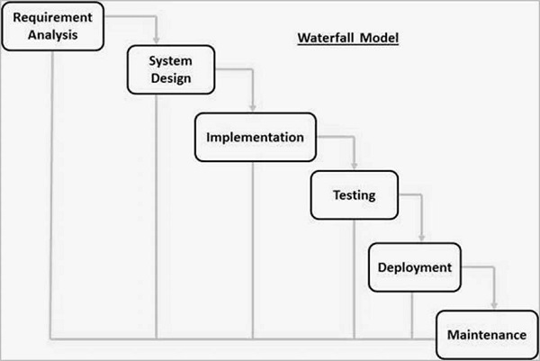
Figure 1 Development methodology (waterfall model)

Report Organization
Report organization describes the organization of report i.e., what the different topic does and what the purpose of it. In this report generally, there is five important topics, Introduction, Background study and literature review, System analysis and design, Implementation and testing and Conclusion and future recommendation.
Chapter-1 describes how the system will recommend the user. It also includes the description about why this system was develop with objective of the system aims to fulfill. Similarly scope and limitation of project are also defined.
Chapter-2 constitutes of review of several research paper that have been study together knowledge about Loan Eligibility Prediction. Several papers regulate to Loan Eligibility Prediction are reviewed. Requirement analysis and feasibility study are discussed.
Chapter-3 describes the overall structure, interface and processing steps involved in the application. Input and output design of the system is explained.
Chapter-4 includes the listing and description of the algorithms used in the application for proper functioning of the application.
Chapter-5 contains a detailed description of overall project completion to show how much project is completed, and how much work is left to do.

Chapter 2: Background Study and Literature Review

2.1 Background Study
Plagiarism has become a growing concern in academic institutions due to the increased availability of digital documents and ease of copying electronic content. In higher education, final year project reports play a crucial role in evaluating a student’s understanding of research, problem-solving, and technical skills. Ensuring the originality of these reports is essential for maintaining academic standards and institutional credibility.
Traditionally, plagiarism detection in many colleges, including NCCS, is performed manually by supervisors or evaluation committees. This approach relies heavily on human memory and visual inspection, which is inefficient and unreliable when dealing with a large number of documents submitted over multiple academic years. As the volume of archived project reports increases, manual comparison becomes practically impossible.
Commercial plagiarism detection tools such as Turnitin and iThenticate are widely used internationally. However, these tools are often costly, depend on external databases, and may not allow institutions to maintain full control over their internal academic documents. Additionally, internet-based plagiarism checkers may not effectively detect similarities between previously submitted institutional reports if those documents are not publicly available.
The background study highlights the need for a localized plagiarism detection system that focuses specifically on internal academic documents. By maintaining a centralized repository of past final project reports and applying automated text similarity techniques, NCCS can efficiently detect repeated content across batches while preserving data privacy and reducing dependency on third-party tools.

2.2 Literature Review
Plagiarism detection has been extensively studied in the field of Natural Language Processing (NLP) and information retrieval. Research commonly categorizes plagiarism detection techniques into lexical, syntactic, semantic, and hybrid approaches. Among these, lexical-based methods are widely adopted due to their simplicity, computational efficiency, and effectiveness in identifying direct text reuse. Lexical techniques focus on analyzing surface-level text patterns rather than deeper semantic meaning, making them practical for institution-level plagiarism detection systems.
One of the most commonly used lexical techniques is N-gram analysis, where a document is divided into contiguous sequences of words or characters known as N-grams. Studies have shown that N-gram–based approaches are highly effective in detecting copy-paste plagiarism and minor textual modifications. By representing documents as sets of N-grams, similarities between documents can be efficiently identified through set comparison methods. This technique is particularly suitable for large document repositories due to its straightforward implementation and scalability.
Similarity between documents in N-gram–based systems is frequently measured using Jaccard similarity. Jaccard similarity calculates the ratio of the intersection of N-gram sets to their union, providing a normalized similarity score between 0 and 1. Research indicates that this method is computationally efficient and reliable for detecting overlapping textual content. Because of its balance between accuracy and performance, the combination of N-gram analysis with Jaccard similarity is considered a practical and effective solution for academic plagiarism detection systems.

Chapter 3: System Analysis

3.1 System Analysis
The system analysis for the Plagiarism Detection System involves identifying and evaluating both functional and non-functional requirements to ensure the system effectively addresses the need for automated plagiarism checking at NCCS. Functionally, the system must allow teachers to upload PDF and DOCX project reports, extract and preprocess text, generate N-grams, compute similarity using Jaccard similarity, and display similarity percentages along with matched documents from a centralized repository. Non-functionally, the system must ensure accuracy, reasonable response time, data security, and ease of use. This analysis provides a clear foundation for designing and implementing a reliable, efficient, and institution-focused plagiarism detection solution.

3.2 Requirement Analyis

3.2.1 Functional Requirements
- Teachers can upload previously submitted final project reports
- Teachers can upload new student project reports
- The system extracts text from PDF and DOCX files
- The system preprocesses the extracted text
- The system compares the new report with stored reports
- The system generates a plagiarism (similarity) report
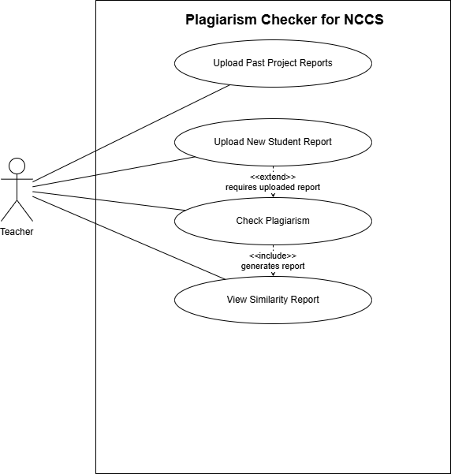
Figure 2 Use Case Diagram

Use Case Description
The use case diagram for the Plagiarism Checker for NCCS illustrates the interactions between a single actor, the Teacher, and the system. The Teacher can upload past project reports to build the system’s reference database and upload a new student report for evaluation. After uploading a new report, the Teacher initiates the plagiarism checking process, which analyzes the document against stored reports. The “Check Plagiarism” use case includes the generation of a similarity report, allowing the Teacher to view detailed results. Additionally, checking plagiarism extends from uploading a new student report, as the plagiarism check requires a report to be uploaded first. Overall, the diagram shows how the Teacher uses the system to manage reports and detect similarities efficiently.

3.2.2 Non-functional Requirements
- The system should provide accurate similarity detection
- The system should respond within reasonable time
- The system should ensure data security and access control
- The system should be easy to use for teachers

3.3 Feasibility Analysis

3.3.1 Economic Feasibility
The project uses open-source technologies and does not require paid software licenses, making it cost-effective.

3.3.2 Technical Feasibility
The system will be developed using Python and open-source NLP libraries, which are well-supported and widely used. Required tools and technologies are readily available.

3.3.3 Operational Feasibility
Teachers can easily operate the system through a simple web interface without requiring specialized technical skills.

3.3.4 Schedule Feasibility
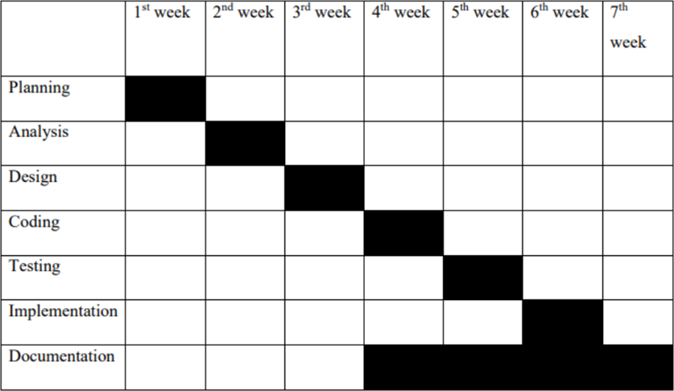
The project can be completed within the academic timeline by following a structured development plan.
Figure 3 Gantt Chart

3.4 Analysis (Object oriented approach)

3.4.1 Object Modelling

3.4.1.1 Class Diagram
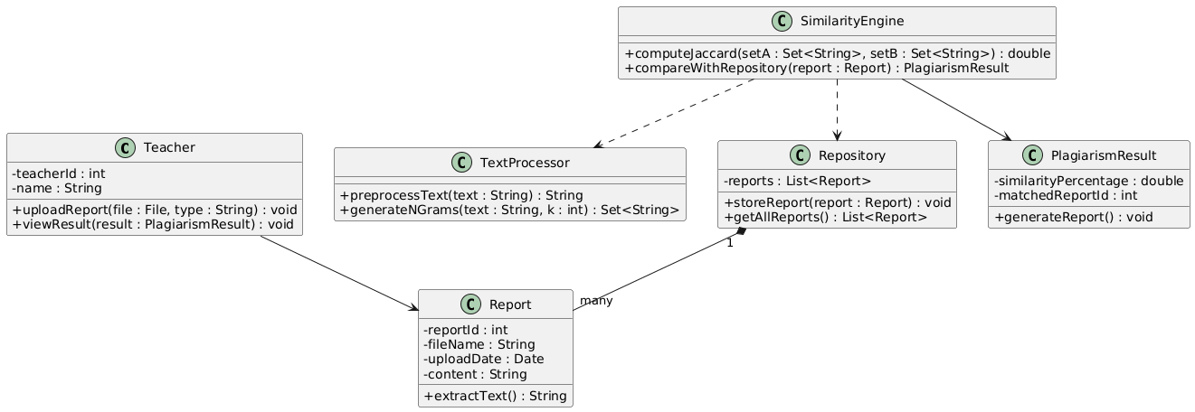
Figure 4 Class Diagram

3.4.1.2 Object Diagram
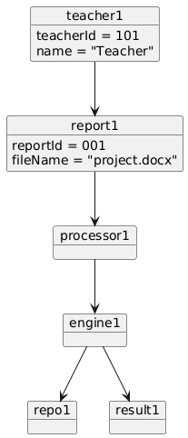
Figure 5 Object Diagram

3.4.2 Dynamic Modelling

3.4.2.1 Sequence Diagram
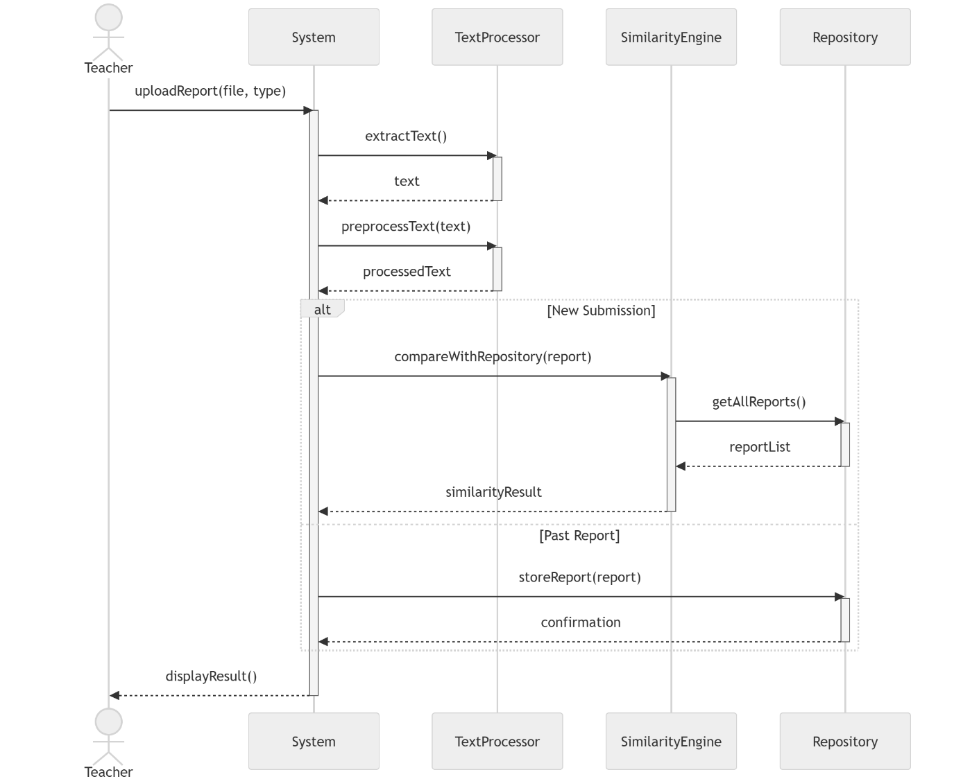
Figure 6 Sequence Diagram

3.4.2.2 State Diagram
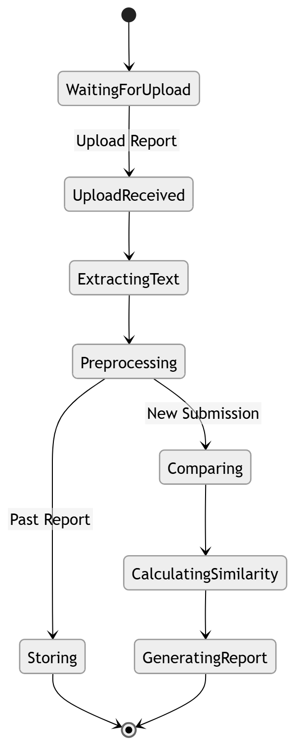
Figure 7 State Diagram

3.4.3 Process Modelling

3.4.3.1 Activity Diagram
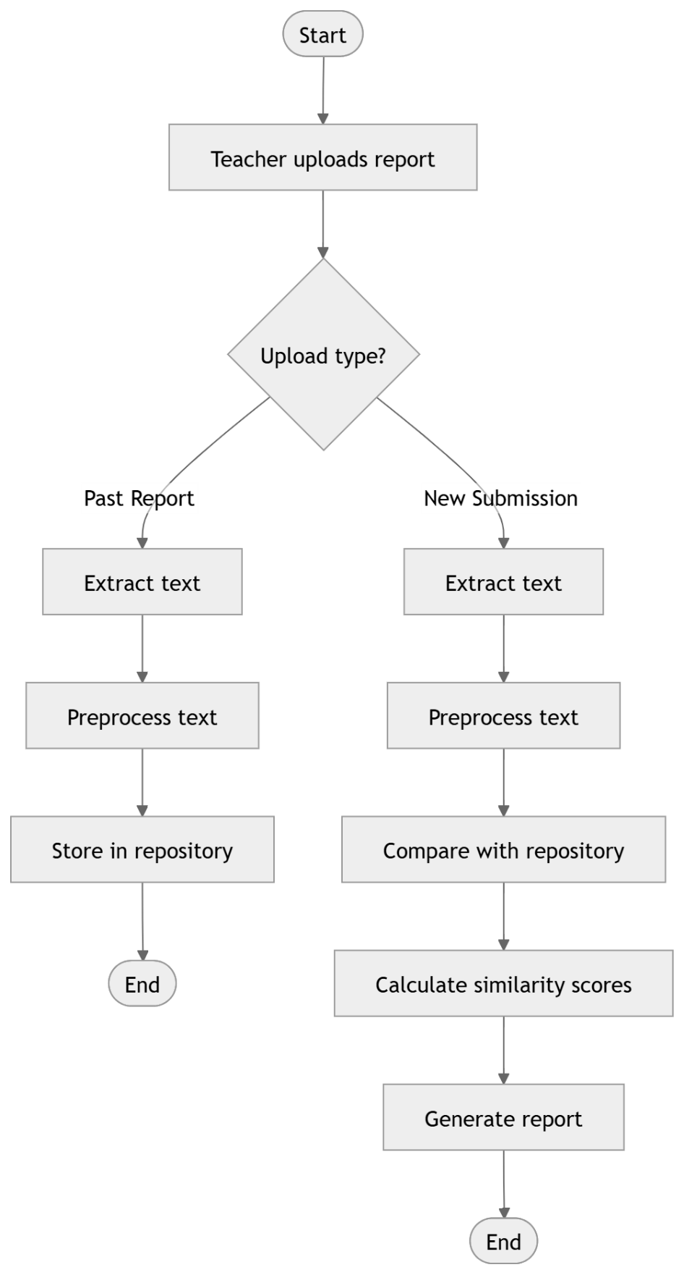
Figure 8 Activity Diagram

Chapter 4: Algorithms Used
The project implements the following algorithm for plagiarism detection:

4.1 N-Gram Based Similarity with Jaccard Similarity
The proposed system uses an N-gram–based text similarity algorithm combined with Jaccard similarity to detect plagiarism. This is a lexical-based technique that focuses on identifying overlapping word sequences between documents. It is particularly effective in detecting direct copy-paste plagiarism and minor text modifications.
The algorithm works by converting documents into sets of contiguous word sequences (N-grams) and then measuring the similarity between two documents based on the overlap of these N-gram sets.
N-Gram with Jaccard Similarity Algorithm Overview
- Data Preparation
The algorithm begins with two documents:
- A newly submitted project report
- Previously stored project reports in the repository
The documents are uploaded in PDF or DOCX format and text is extracted from them.
- Text Preprocessing
Before generating N-grams, the extracted text undergoes preprocessing to improve comparison accuracy:
- Convert text to lowercase
- Remove punctuation and special characters
- Remove extra whitespace
- Optional stop-word removal
This ensures uniform formatting and reduces noise in the data.

- N-Gram Generation
After preprocessing, the text is divided into contiguous sequences of k words, known as N-grams.
For example, if k = 3 (3-gram):
Text: “plagiarism detection system project”
Generated 3-grams:
- plagiarism detection system
- detection system project
Each document is represented as a set of N-grams.

- Jaccard Similarity Calculation
The similarity between two documents is computed using Jaccard similarity, which measures the overlap between two N-gram sets.
Jaccard Similarity Formula:
$$J(A,B)=\frac{∣A∩B∣}{∣A∪B∣}$$
Where:
- $A$= Set of N-grams from document 1
- $B$= Set of N-grams from document 2
- $∣A∩B∣$= Number of common N-grams
- $∣A∪B∣$= Total unique N-grams in both documents
The result ranges between 0 and 1:
- 0 → No similarity
- 1 → Identical documents
The value is then converted into a percentage.

- Similarity Comparison with Repository
For a new submission:
- Its N-gram set is compared with the N-gram sets of all stored reports
- Jaccard similarity is calculated for each comparison
- The highest similarity score is identified
This ensures detection of the most similar existing document.

- Decision and Report Generation
Based on the calculated similarity percentage:
- The system classifies the similarity level (e.g., low, moderate, high)
- The matched document ID is recorded
- A plagiarism report is generated and displayed to the teacher
Conclusion of the Algorithm
The N-gram with Jaccard similarity approach is computationally efficient, simple to implement, and well-suited for institutional plagiarism detection systems. It effectively detects direct textual overlap while maintaining good performance even with large document repositories.

Chapter 5: Overall Project Completion
Estimated Completion: 50%
Remaining Work: 50%

5.1 Completed Work (50%)
- Project Setup and Configuration (100% Complete)
- Django project initialized
- Application structure created
- Database connected
- Media file storage configured
- Admin panel working
Foundation layer is complete.
- Report Upload System (80% Complete)
Implemented:
- Upload form
- Report type selection (Past / New)
- File storage in media folder
- Database entry creation
- Content extraction logic
Still Needs:
- Strong validation
- Error handling for unsupported files
- Better UI feedback
- Repository Structure (60% Complete)
Implemented:
- Logical repository using report_type='past'
- Stored in database
- Visible in Django Admin
Still Needs:
- Repository management (delete/edit reports)
- Better organization system
- Plagiarism Detection Engine (60% Complete)
Implemented:
- Jaccard Similarity algorithm
- Comparison of new submission with all past reports
- Similarity percentage calculation
- Highest similarity detection
Still Needs:
- Text preprocessing (cleaning, normalization)
- Stopword removal
- Accuracy improvement
- Threshold-based plagiarism classification

- Result Display Module (50% Complete)
Implemented:
- Similarity percentage display
- Detailed comparison table
Still Needs:
- UI design improvement
- Color-based plagiarism level
- Clear interpretation (Low/Medium/High plagiarism)
- Report download option

Work Remaining (50%)
- Algorithm Enhancement
- Improve text preprocessing
- Tokenization refinement
- Improve comparison accuracy

- Frontend Improvement
- Professional UI design
- Styling with CSS or Bootstrap
- Improved result visualization
- Navigation improvements

- Performance and Logic Optimization
- Avoid redundant comparisons
- Manage old submissions
- Optimize database queries

